

**THE BRENTSIDE BULLETIN**

**Date:** 17th April 2020

**ACTIVITIES IN SCHOOL**

As you may be aware, Brentside has remained open for selected children over the past few weeks, in order to support the vital work of key workers in our community.

Staff have been working hard to plan creative, academic, and athletic activities, and the children have taken part in days themed around art, cooking, music, PE, drama and ICT (and more!).

The children have thrown themselves in to this huge variety of tasks with great enthusiasm in such unusual circumstances, and have produced some beautiful artwork, crafts and tasty treats to take home to their hard-working parents and guardians.

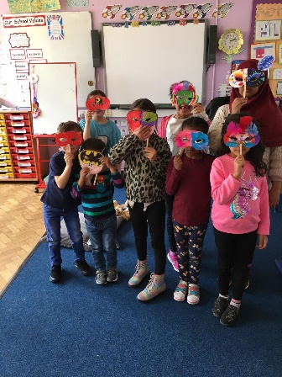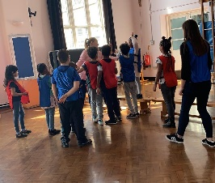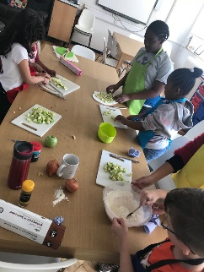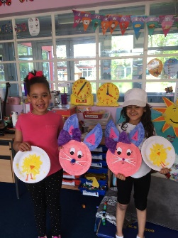**Drama lesson
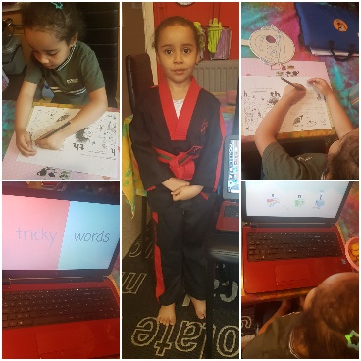** **Issue:** 022

**ACTIVITIES AT HOME**

It has been wonderful to hear from some of you about the exciting creative and academic projects you have been getting up to while learning at home.

Here are some of the brilliant photos that have been sent in by our pupils. By the looks of it, you are all keeping hard at work and finding wonderfully creative ways to keep busy; with geography, art, nature trails, and P.E with Joe Wickes every morning just some of the activities you’ve told us about! Please keep sending your messages and pictures into us at: [admin@brentsideprimary.ealing.sch.uk](mailto:admin@brentsideprimary.ealing.sch.uk)

**MESSAGE FROM THE HEADTEACHER**

Hello everyone, I hope that you are all doing the best that you can under difficult circumstances.

I personally miss you all very much and hope that we can all be back in school again soon.

The teachers are working really hard to make sure that children have work to do whilst they are not in school. Our website has lots of fun learning ideas too.

Please make sure that your children do a little of something each day. It is important that they keep up with their learning and keep their brains working.

However it is really important that you have some fun times too.

Please stay safe and follow the government guidance.

**FREE SCHOOL MEALS**

The Government scheme to provide food vouchers for those children entitled to free school meals is now up and running, through their partner, Edenred.

Families who have been contacted by us should soon receive an email containing voucher codes but please be patient as they are experiencing a backlog on the system.

If you have not applied for free schools meals but think you may be eligible, please email the school office. FAQs about the scheme are available on the school website.

Guidance on using the Edenred system:-

<https://primarysite-prod-sorted.s3.amazonaws.com/brentside-primary-academy-school/UploadedDocument/7a0f188d074446faa5e9aea392f67780/dfe-free-school-meals-parentcarer-faqs.pdf>

We will aim to send out further eCodes next week to cover a 2 week period.



**COVID-19 UPDATES**

The school website continues to be updated regularly with home learning sheets and suggestions of useful websites.

For all updates Visit: <https://www.brentsideprimaryacademy.co.uk/covid-19-information-to-parents/> .

We have recently added more suggestions of resources for parents of children with additional needs, some advice on how make sure children stay safe online, and the details of some online sessions from our after-school club, Kidszone Adventures.

Teachers will update Purple Mash and set new tasks once a week. If you are having any technical difficulties with Purple Mash, some troubleshooting advice and details of the support team are available on our school website too.

**THANK YOU NHS!**

Our pupils have shown their appreciation for the vital work our amazing NHS and carers are doing during this crisis by producing these wonderful posters and rainbow. These are proudly displayed on our school gates so everyone can see how grateful we all are for the tireless efforts of our medical heroes.

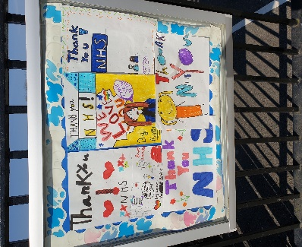

**UPCOMING EVENTS**

We will keep you regularly updated as much as possible with any developments using the school website and via text message

**KEEPING IN TOUCH**

Emails continue to be checked regularly so please let us know if we can support you in any way, and we will try our best to answer any questions you may have.

Please also keep sending in ideas, news and pictures of things that you are doing at home.

Any messages for teachers will be passed on to them and staff would be delighted to hear from pupils.

**Email:**[admin@brentsideprimary.ealing.sch.uk](mailto:admin@brentsideprimary.ealing.sch.uk)