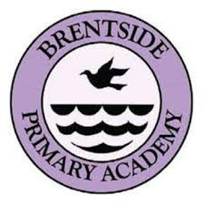

BRENTSIDE’S ‘MAKE A BOOK CHALLENGE’

Your challenge has 3 parts:

Part 1:

Read at least 3 books (nonfiction) that you enjoy. These can be books that you have read before or something completely new. These can be online books or ones that you have at home. When you read the books, think about what you like about them, what makes them interesting and what you would change if you were the author.

Part 2:

Decide on a book that you are going to create. You will need to think about whether a topic and what you will need to use to make your book.

Part 3:

Make your book. Use any resources that you have around your home or you can use a computer. Think carefully about what you need in your book: does it have pictures, contents, index and a glossary.

Once you have made your book, send some pictures into the school [admin@brentsideprimary.ealing.sch.uk](mailto:admin@brentsideprimary.ealing.sch.uk)

When the school reopens, bring your homemade book in with you and we will put them on display

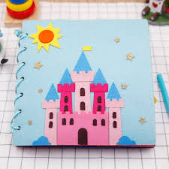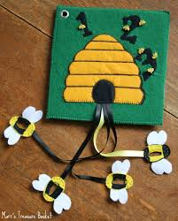

Happy creating!!

Some useful resources that you may find around your home to help:

* Paper bags
* String
* Magazines
* Food packaging
* Milk bottles
* Painting
* Cloth

