|  |  |
| --- | --- |
| **Daily tasks** | |
| I have read my reading book and library book with an adult. |  |
| I have practiced CVC word cards and high frequency word cards. |  |
| I have practiced reading and writing tricky words. |  |



Reception HOME

LEARNING



**Wednesday**

**Literacy-** Today we are looking at sad - read the page to your child below and talk about how and when you feel sad. Ask your child to write this down and draw a picture.

**Maths**- Today using the 100 square attached count in 5’s to 60 and colour in the square. ie 1,2,3,4,**5** colour in and continue.

**Monday**

**Literacy –** Today can you write a sentence or two about what you did on the weekend and draw a picture. (Sheet below)

**Maths-** This week in maths we are looking at counting in 2’s 5’s and 10’s. Today using the 100 square attached count in 2’s to 30 and colour in the square. ie 1,**2** colour in and continue.

**Thursday**

**Literacy-** Today we are looking at Angry - read the page to your child below and talk about how and when you feel angry. Ask your child to write this down and draw a picture.

**Maths-** Today using the 100 square attached count in 5’s from 60 to 100 and colour in the square. ie 1,2,3,4,**5** colour in and continue.

**Tuesday**

**Literacy-** Our topic this half term is feelings. Today we are looking at Brave- read the page to your child below and talk about how and when you feel brave. Ask your child to write this down and draw a picture.

**Maths -** Today using the 100 square attached count in 2’s from 30 to 50 and colour in the square. ie 1,**2** colour in and continue.

**Friday**

**Literacy-** write a feelings log about how you are feeling today. I am feeling …….. because…….

**Maths-** Today using the 100 square attached count in 10’s to 100 and colour in the square. ie **10,20,30,40,** **50** colour in and continue.

What did you do at the weekend?

Monday work

______________________________________________________________________________________________________

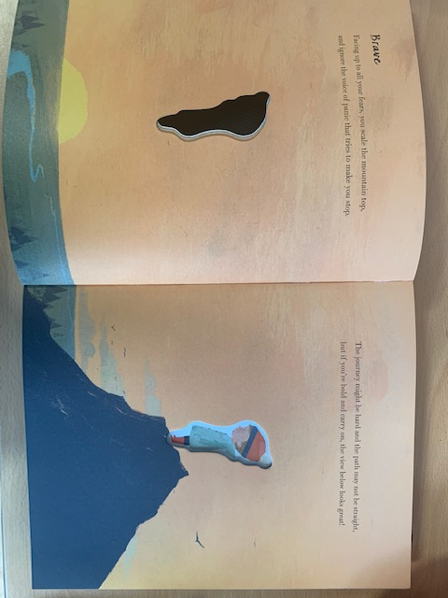

Tuesday work

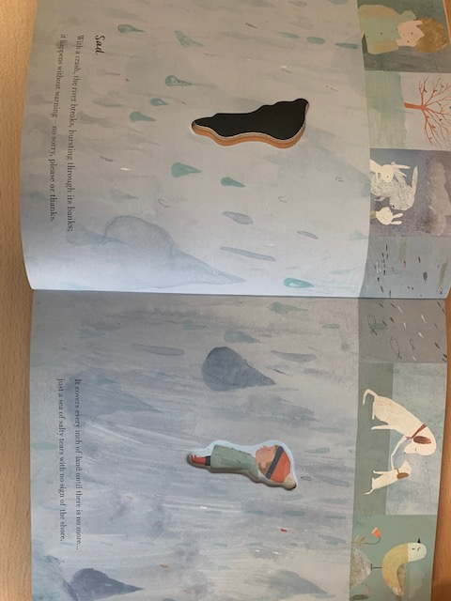

Wednesday work

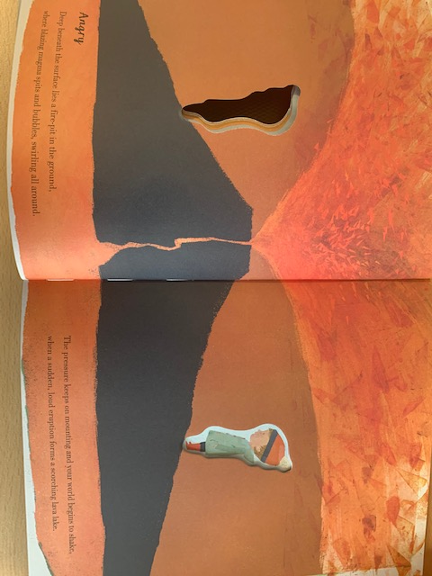

Thursday work

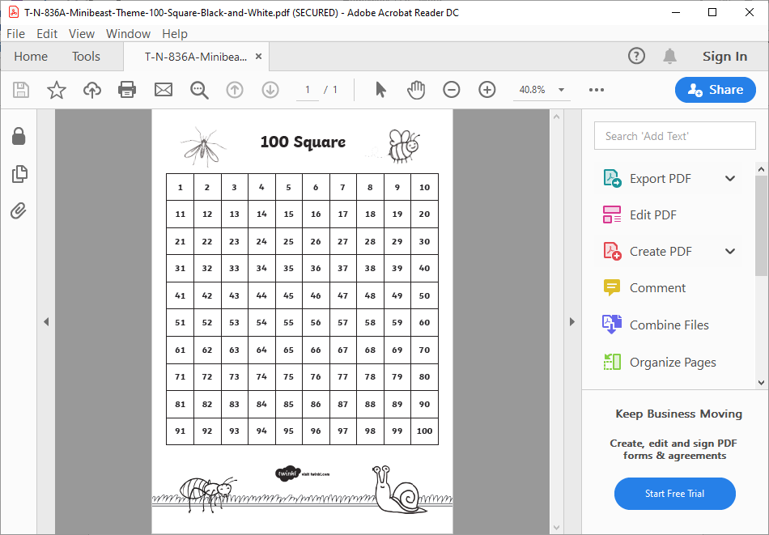

Math’s work

Can print off for daily activity on sheet.