|  |  |
| --- | --- |
| **Daily tasks** | |
| I have read my reading book and library book with an adult. |  |
| I have practiced CVC word cards and high frequency word cards. |  |
| I have practiced reading and writing tricky words. |  |



Reception HOME

LEARNING



**Wednesday**

**Literacy-** Today we are looking at Jealous - read the page to your child below and talk about how and when you feel sad. Ask your child to write this down and draw a picture.

**Maths**-When you go to the shop shopping talk to your child about money and let them pay for some shopping or an item.

**Monday**

**Literacy –** Today can you write a sentence or two about what you did on the weekend and draw a picture. (Sheet below)

**Maths-** this week in maths we are looking at money and recognising coins. Today complete sheet attached matching coins to amounts.

**Thursday**

**Literacy-** Today we are looking at Excited - read the page to your child below and talk about how and when you feel angry. Ask your child to write this down and draw a picture.

**Maths-** play <https://www.topmarks.co.uk/money/coins-game> with your child. You can choose all options when playing.

**Tuesday**

**Literacy-** Our topic this half term is feelings. Today we are looking at happy - read the page to your child below and talk about how and when you feel brave. Ask your child to write this down and draw a picture.

**Maths –** Today look around the house for different coins and talk about what you used money for. You can do a coin rubbing activity. Put a coin under paper and use a pencil to colour over.

**Friday**

**Literacy-** write a feelings log about how you are feeling today. I am feeling …….. because…….

**Maths-** Role play ‘Shop’ with your child using money up to 50p

What did you do at the weekend?

Monday work

______________________________________________________________________________________________________

Monday maths

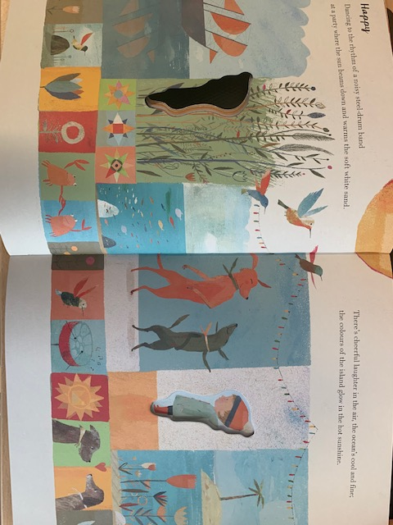

Tuesday work

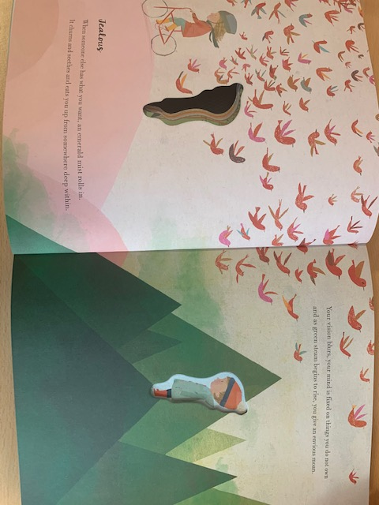

Wednesday work

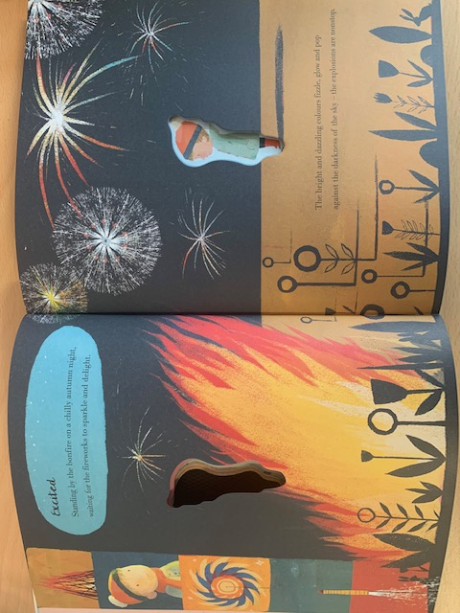

Thursday work

Thursday work