**PE SPORTS GRANT**

**2015-18**

**2015-16 Report**

**Allocated Grant**

Grant Amount £9,580

**2015-16 Use of Grant**

|  |  |
| --- | --- |
| **Activity** | **Cost** |
| Dance Teacher | £8,180 |
| Cricket Equipment | £293.38 |
| Early Years Games | £499.99 |
| Benches | £800.00 |
| **Total** | **£9,773.37** |

**Effect of the PE & Sports Grant on participation, attainment & sustainability**

All children in KS2 took part in dance classes once a week, ensuring that a wide range of children were able to benefit from the grant.

However, a number of the male pupils in KS2 did not enjoy taking the dance classes- the opposite effect of what we were trying to achieve.

It was decided that the dance lessons would be stopped and a different approach utilised the following year.

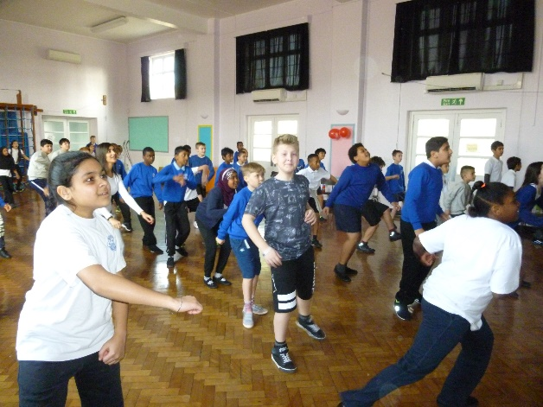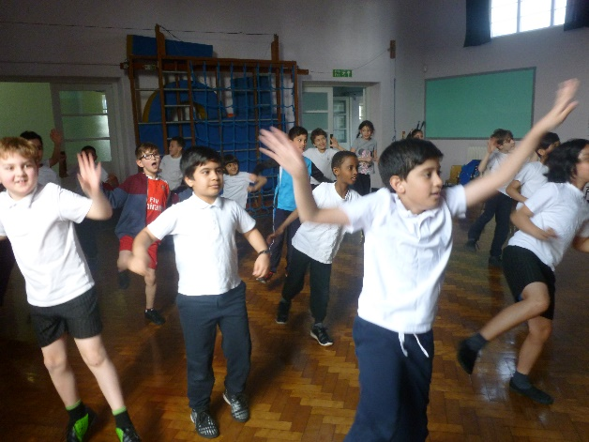

**2016-17 Report**

Grant Amount £9700

**2016-17 Use of Grant**

|  |  |
| --- | --- |
| **Activity** | **Cost** |
| **After School clubs Autumn & Spring- Overtime to TAs** | **£500** |
| **On the Ball Sports Coaching- After School clubs** | **£900** |
| **Skipping workshop 20** | **£270** |
| **JD Sports Coaching- Lunchtime clubs** | **£1,350** |
| **Freestyle football workshop** | **£511** |
| **GLS- Tennis rackets and nets (equipment for clubs)** | **£680** |
| **GLS- Footballs & Basketballs (equipment for clubs)** | **£388** |
| **Total** | **£4,600** |

*NB: Not all of the grant was utilised in 2016-17 but will be carried forward and used in 2017-18 instead*

**Effect of the PE & Sports Grant on participation and attainment & sustainability**

BPA introduced a number of initiatives and activities to utilise the PE & Sports Grant last year

* Professional coaches for after school clubs in the Summer Term- KS2
* Professional coaches for lunch time clubs in the Summer Term – Yr 2 & Yr 6
* Skipping Workshop- KS1
* Freestyle Football skills workshop- KS2

BPA worked with On the Ball Sports Coaching to provide after school multisports clubs for KS2 children. The clubs were run during the Summer Term for 3 days a week.

These clubs were very popular with the KS2 children as they provided a variety of different sports with professional sports coaches. Unfortunately, we were let down by the coaches on a number of occasions and will not be using their services in the future.

The Yr2 & Yr6 children that took part in the lunchtime basketball club learned a lot of skills and were very enthusiastic about the coach and the club.

**Sustainability**

Moving forward we have arranged with JD coaching to offer after school clubs and lunch time clubs for the whole of the next academic year. The lunch time clubs will be extended to include Year 1 pupils as well.

We will also be undertaking sports related workshops to introduce more sports, as the pupils enjoyed learning new skills.

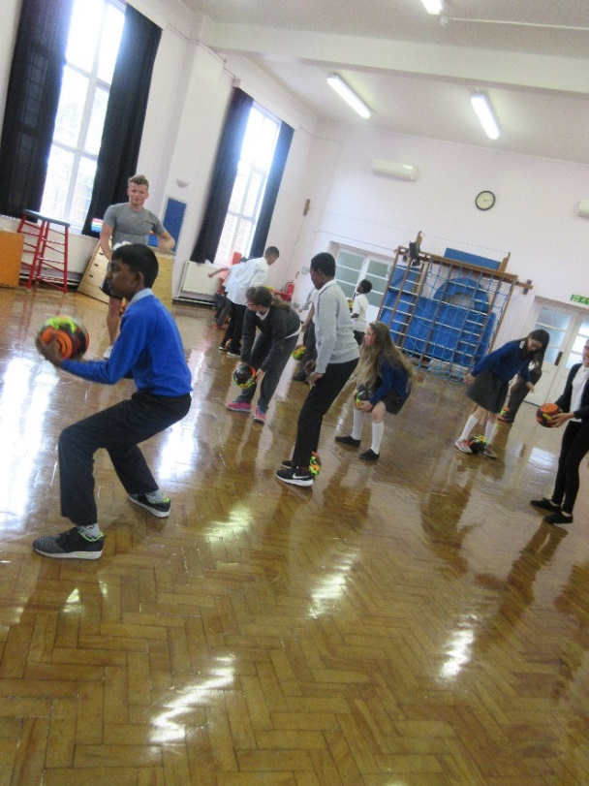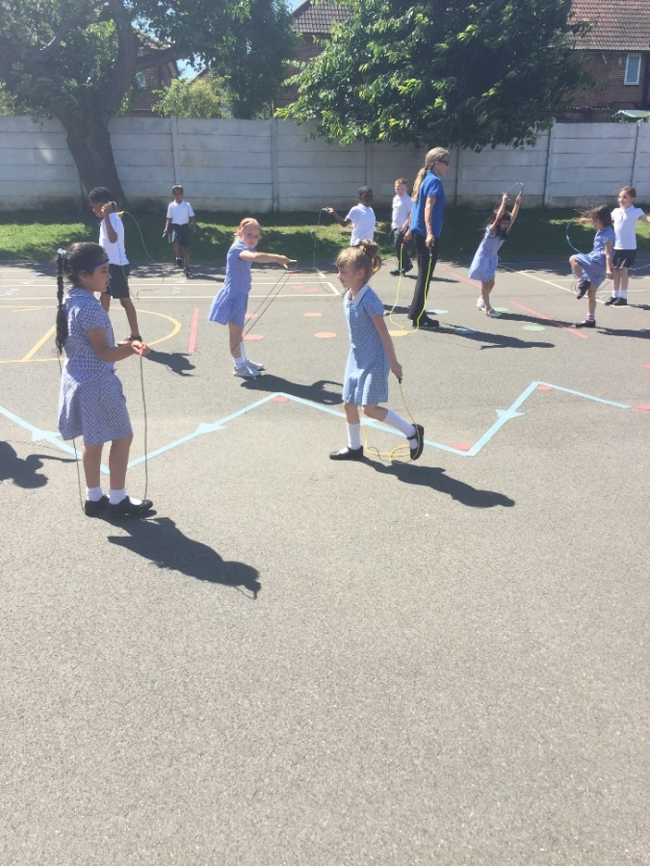

**2017-18 Planned Use of Grant**

Estimated Grant Amount £9,750

Unspent Grant from 2016-17 £5,100

Total PE & Sports Grant 2017-18 £14,850

**2017-18 Planned Use of Grant**

|  |  |
| --- | --- |
| **Activity** | **Cost** |
| **JD Sports Coaching-After School clubs KS2 Autumn, Spring & Summer** | **£7,200** |
| **JD Sports Coaching-Lunchtime clubs KS1 Autumn, Spring & Summer** | **£2,700** |
| **JD Sports Coaching-1 day per week class PE support and teacher instruction to improve the quality of PE lessons provided by BPA** | **£3,950** |
| **Sports related Workshops** | **£1,000** |
| **Total** | **£14,850** |

