**BPA Challenges you! Wk1**

**Over the past few months, staff and pupils have continued to work hard on areas of the curriculum that they would have been exploring and learning in school. Well done to everyone who continued to access the home learning sheets, you should all be proud of your determination to learn and succeed.**

**For the remaining few weeks of term, we will be setting some home learning challenges around some interesting themes. We have chosen these themes based on our school values, our excting curriculum and current events that have been happening in the world.**

**Early Years activity ideas:**

* **Create a collage using things that you can find around the house to show all the things that you like.**
* **Make a bracelet for a family member that represents all the important and special things about your family.**
* **Look at photos of yourself when you were a baby, can you list the ways that you have changed?**

**KS1 activity ideas:**

* **Make a self portrait of yourself using breakfast cereals such as cheerios or rice crispies.**
* **Choose a word or phrase to describe yourself, write it in big letters and then decorate it.**
* **Can you draw an image of the people that live in your house? Choose paint, pens of pencils to colour it in.**

**OUTLINE OF THE CHALLENGE:**

**Who Are We?**

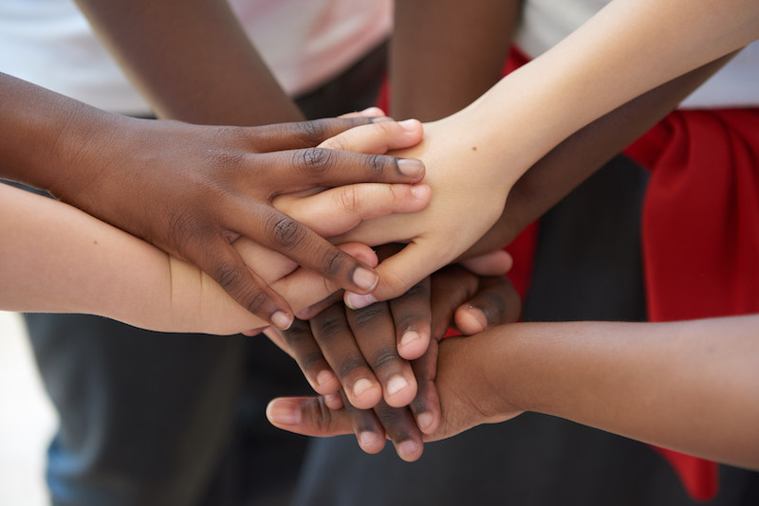

The TATE MODERN have launched a project to celebrate the diversity in our classrooms and communities. They want pupils to celebrate what makes themselves special and important and to find their voice within society.

Your task this week is to create a piece of artwork to celebrate who you are. Consider both the visible and invisible parts of you and tell your own story and the story of the people who are important to you.

**An extra challenge:**

**BPA is proud of the diversity of its school community and how we behaved towards one another.**

* **One of our school values is respect. Can you draw a small image to show what respect means to you?**

**SOME USEFUL RESOURCES OR WEBSITES TO USE:**

<https://www.tate.org.uk/kids/explore/who-is/who-lubaina-himid>

<https://www.tate.org.uk/whats-on/tate-modern/exhibition/bmw-tate-live-exhibition-2020>

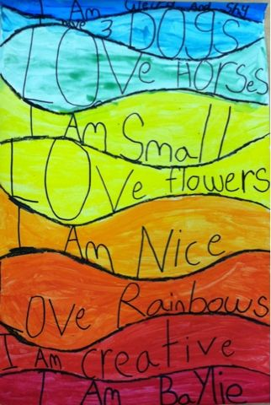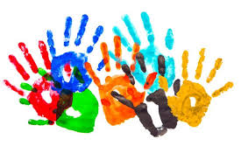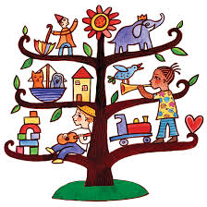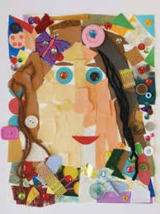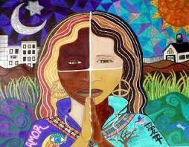

**KS2 activity ideas:**

* **Draw an image of yourself and then split it into 4 and colour each one to show a different emotion that you sometimes feel.**
* **Create a collage of your family that shows your cultural background. Try to include a range of mediums such as textiles, magazines and things that you might find outside.**
* **Find a quote from somebody that you admire and represent it in a piece of artwork.**